

Lease Deed - User Stories & Wireframes

Contents
Changes 2
User Stories- Lease Deed Process 3
1. User Story- Generate Property Checklist 3
1.1 Mock-ups 4
2. User Story- Add Lease Deed Details 5
2.1 Mock-ups 7
3. User Story- View Lease Deed Details 7
3.1 Mock-ups 8
4. User Story – Generate Lease Rent Challan 9
4.1 Mock-ups 11
5. User Story- Calculate Lease Rent 11
5.1 Mock-ups 13

Changes

S NO | MODULE | DESCRIPTION | Date
1 | 1,4,5 | Changed entire user stories and mockups. | 25/06/2016
2 | 1 | Removed BR | 25/06/20116
3 | 2 | Updated BRs | 25/06/20116
4 | 1 | Updated the user stories of generate checklist, Add and View lease deed details. | 25/06/20116
5 | All | Mockups Updated for:  Generate Lease deed  Add Lease deed  View Lease deed  Updated Manage Lease deed grid.  Lease Rent menu page. | 25/06/20116
6 | 4 | Removed functionality of Lease rent Schedule | 25/06/20116
7 | All | Changed the order of the menus and user stories. | 25/06/20116

User Stories- Lease Deed Process

User Story- Generate Property Checklist

Sprint | 4
User Story ID | 01
User Story Title | Generate Property Checklist
Actors | Department user
Story | As a department user, I want to generate checklist for particular department and property type.
Pre Conditions | - User should have required access rights.  - Printer should be connected to the LAN.
Business Criteria
Acceptance Criteria | - User would click on “Checklist” from the navigation panel and would get a form.  - User would then select “RID” from the dropdown and below fields would be displayed under “Allottee Details” section:  - Allottee Name: Label  - Father Name: Label  - Department: Label  - Property Type: Label  - Property Number: Label  - Property Cost: Label  - Allotment Money: Label  - Allotment Date: Label"  - User would then update the following fields from dropdown available under “Select Checklist” section:  - Checklist Type: Dropdown, mandatory  - Checklist Date: Date picker, mandatory  - User would click on “Generate Checklist” button. The system would then generate and display the checklist on the application screen.  - User would have the options to save the file to his local system by clicking on ‘Download’ button or print checklist by clicking on ‘Print’ button.  - The options available in “Checklist Type” dropdown are:  - Transfer  - Lease deed  - The options available in “Property Type” dropdown are from Property type table in database.
Field level Validation

Mock-ups

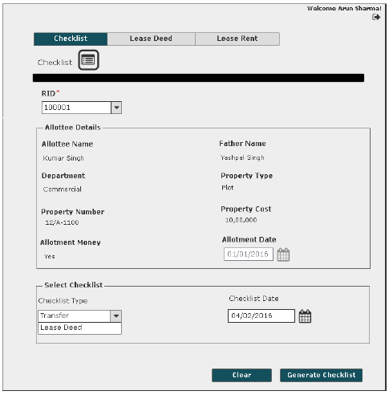

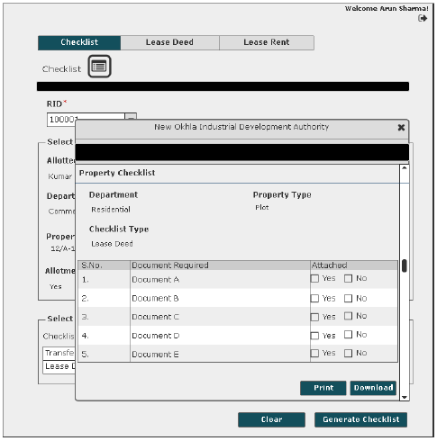

User Story- Add Lease Deed Details

Sprint | 4
User Story ID | 02
User Story Title | Add Lease Deed Details
Actors | Department user
Story | As a department user, I want to add lease deed details for a property in system.
Pre Conditions | - User should have required access rights.
Business Criteria | - Lease deed would only be executed for allotted properties.  - Lease deed would only be executed if allotment money is paid.  - Lease deed would only be executed if there are no dues till date.  - Lease rent would start after the successful completion of lease deed.  - The rate of the lease deed stamp value will be charged as per selection of stamp duty.
Acceptance Criteria | - User would click on “Add Lease Deed” button under the lease deed menu.  - User would get a form with label as “Add Lease Deed”. User would then select “RID” from the dropdown and would be displayed with below fields:  - Allottee Name: Label  - Father Name: Label  - Department: Label  - Property Type: Label  - Property Number: Label  - Property Cost: Label  - Stamp Duty Amount (INR)  - Duplicate Stamp Value: Label  - Previous Dues (INR)  - Balance Due till date  - Registry Type: Label  - Lease Deed Due Date: Label  - Lease Deed Execution Date: Date picker, mandatory.  User would update the lease deed execution date for the selected registration ID.  - User would click on the “Add” button to execute lease deed for a property and on successful submission would be displayed with a message as “Lease deed details added successfully”. The details would be displayed in grid on “Lease Deed” screen. Alternatively, on clicking the “Back” button system would return the user to the lease deed screen without saving the details.  - Grid will display following columns:  - RID  - Scheme  - Department  - Lease Deed Status  - Amount Due  - Lease Deed Due Date  - Lease Deed Execution Date
Field level Validation

Mock-ups

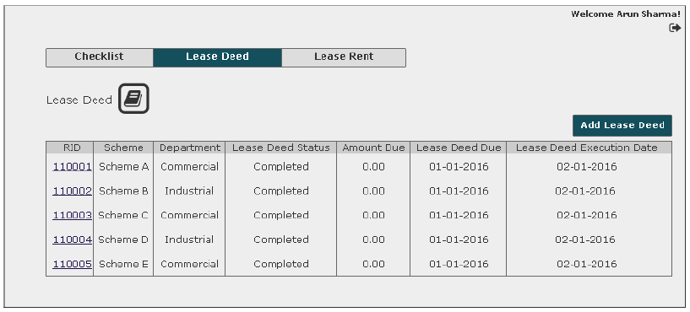

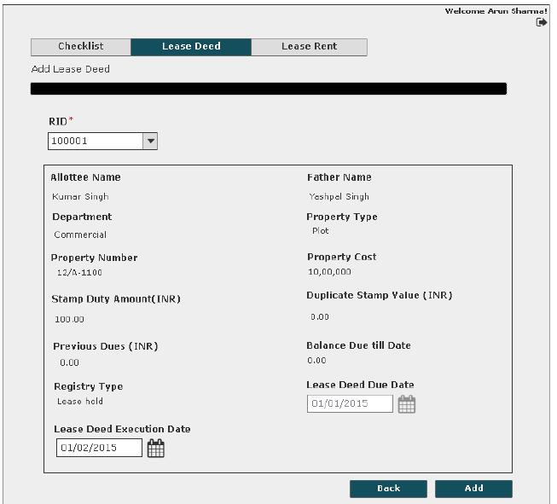

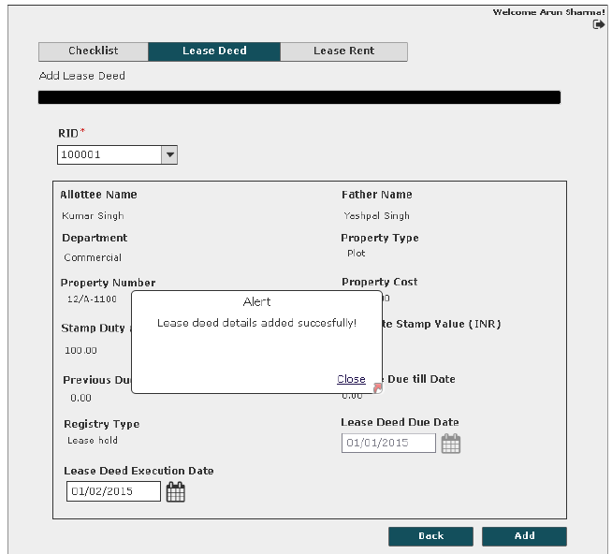

User Story- View Lease Deed Details

Sprint | 4
User Story ID | 003
User Story Title | View Lease Deed Details
Actors | Department user
Story | As a department user, I want to view lease deed details.
Pre Conditions | - User should have required access rights.
Business Criteria
Acceptance Criteria | - User would click on “RID” hyperlink option available in grid for viewing the lease deed details.  - User would get screen with complete lease deed information of the selected property:  - Allottee Name  - Father Name  - Department  - Property Type  - Property Number  - Property Cost  - Stamp Duty Amount (INR)  - Duplicate Stamp Value  - Previous Dues (INR)  - Balance Due till date  - Registry Type  - Lease Deed Due Date  - Lease Deed Execution Date: Date picker, mandatory.  - After viewing the details, user clicks on the “Back” button and system would return the user to the lease deed screen.
Field level Validation

Mock-ups

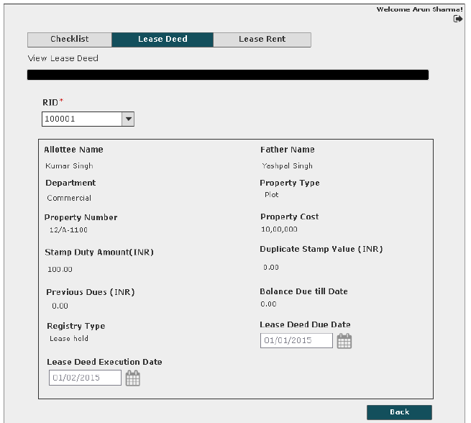

User Story – Generate Lease Rent Challan

Sprint | 4
User Story ID | 004
User Story Title | Generate Lease Rent Challan
Actors | Department user
Story | As a department user, I want to generate lease rent challan for particular registration ID.
Pre Conditions | - User should have required access rights.  - Printer should be connected to LAN.
Business Criteria | - Lease rent would be calculated as per below options:  First option, the allottee can pay the lease money every year. In this instance, lease money is defined percentage of property area multiplied by the current circle rate.  Second option, the allottee can pay lease rent of current year and multiply it with a certain number of years (as decided by the authority from time to time) and that would be considered as ONE TIME lease rent, which is equivalent to lease rent for entire lease duration of a defined time-frame.  In both cases allottee has to pay advance one year lease rent.  Formulas for reference:  [Per Year Lease Money= (PA*CR*PER)/100]  where,  PA=Property Area (Sq.mtr)  CR=Circle Rate  PER=Defined % by authority Rules  One time Lease Money=Per Year Lease Money*Define Year by authority  if late payment of lease rent,  Penal Interest = P*(1+r/100) ^ n  Where,  P = Principal (one year lease rent)  r = rate of interest  n = frequency
Acceptance Criteria | - User would click on the “Lease Rent” from the navigation panel and would get a form.  - User would then select “RID” from the dropdown and would be displayed with below fields and action buttons:  - Allottee Name: Label  - Father Name: Label  - Department: Label  - Property Type: Label  - Property Number: Label  - Property Cost: Label  - Lease Rent Challan button  - Calculate Lease Rent button  - User would then click on “Lease Rent Challan” button. The system would then generate and display the lease rent challan on the application screen.  - User would have the options to save the file to his local system by clicking on ‘Download’ button or print challan by clicking on ‘Print’ button.
Field level Validation

Mock-ups
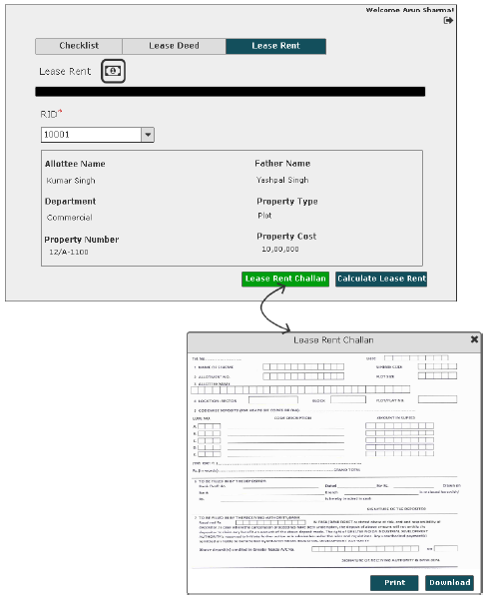

User Story- Calculate Lease Rent

Sprint | 4
User Story ID | 005
User Story Title | Calculate Lease Rent
Actors | Department user
Story | As a department user, I want to calculate the lease rent amount for a property.
Pre Conditions | - User should have required access rights.
Business Criteria | - Lease rent would be calculated as per below options:  First option, the allottee can pay the lease money every year. In this instance, lease money is defined percentage of property area multiplied by the current circle rate.  Second option, the allottee can pay lease rent of current year and multiply it with a certain number of years (as decided by the authority from time to time) and that would be considered as ONE TIME lease rent, which is equivalent to lease rent for entire lease duration of a defined time-frame.  In both cases allottee has to pay advance one year lease rent.  Formulas for reference:  [Per Year Lease Money= (PA*CR*PER)/100]  where,  PA=Property Area (Sq.mtr)  CR=Circle Rate  PER=Defined % by authority Rules  One time Lease Money=Per Year Lease Money*Define Year by authority  if late payment of lease rent,  Penal Interest = P*(1+r/100) ^ n  Where,  P = Principal (one year lease rent)  r = rate of interest  n = frequency
Acceptance Criteria | - User would click on the “Lease Rent” from the navigation panel and would get a form.  - User would then select “RID” from the dropdown and would be displayed with below fields and action buttons:  - Allottee Name: Label  - Father Name: Label  - Department: Label  - Property Type: Label  - Property Number: Label  - Property Cost: Label  - Lease Rent Challan button  - Calculate Lease Rent button  - User would then click on “Calculate Lease Rent” button. The system would display the calculated lease rent amount on the pop up window.  - On clicking on the “Back” button the pop up window will be closed and user will return on the lease rent screen.
Field level Validation

Mock-ups

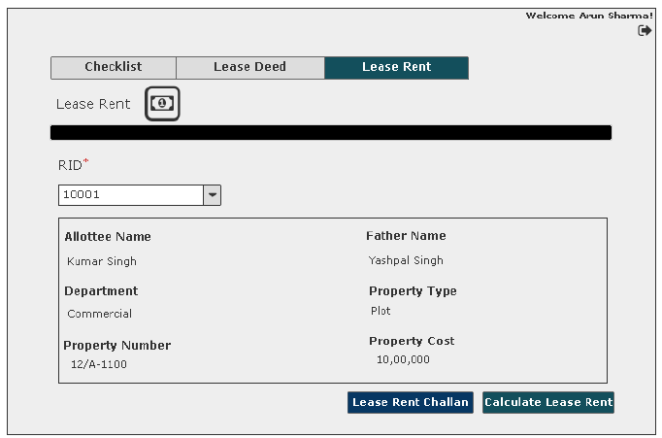
Note: The calculation chart, which would be displayed on the form when user clicks on the “Calculate Lease Rent” will be provided by the database team.

